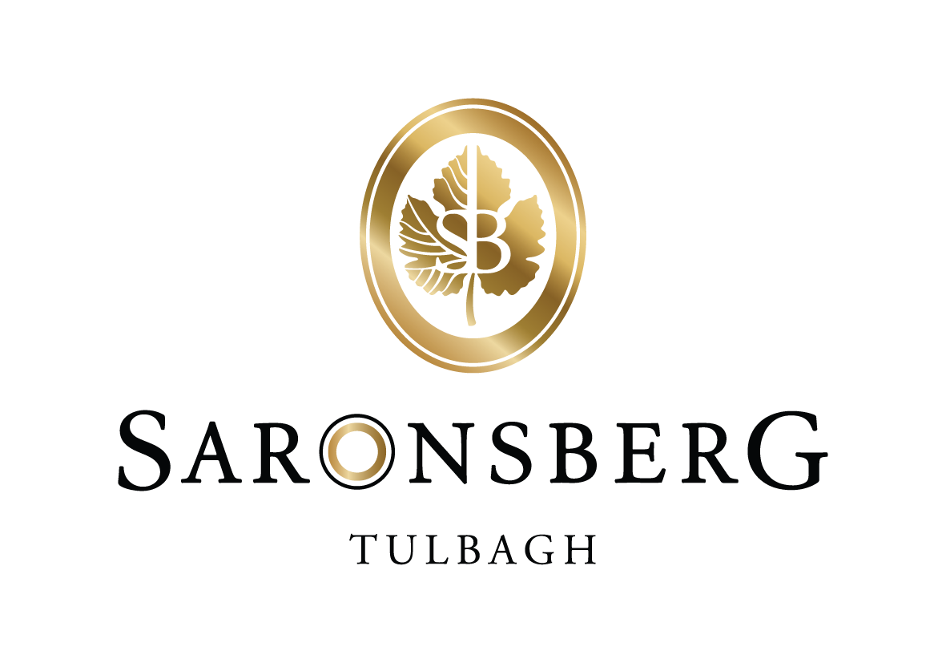

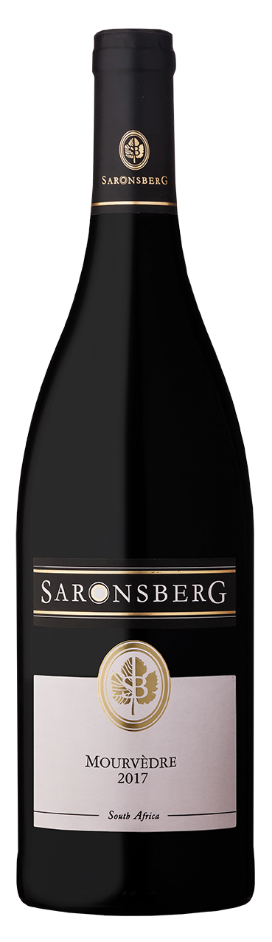

**Mourvèdre 2017**

**Fermentation**

The grapes were hand-picked in the early morning and force-cooled to 4 °C. Then they were bunch-sorted, destemmed and berry-sorted on vibration tables by 25 highly trained staff. On average 70% of the berries were gently crushed (while the rest was kept whole) before being deposited into a satellite tank and transported to a open fermenter. The must was dejuiced by 8% . It was given a cold soak of 3 days at 9 °C protected by a CO2 blanket. The juice was pumped over once daily during this period.

The tanks were then heated to 18 °C and inoculated with L2056 yeast. The fermentation temperature was allowed to peak at 28 °C. The fermenting cap was punched down three times daily and two pump-overs were done per day. Total time on the skins were 18 days. The wine was then pressed into second-fill 300 liter Allier French oak barrels. The press fraction was separated. Malolactic bacteria were inoculated and malolactic fermentation was completed in the barrels.

After malolactic fermentation, the wines were given a low sulphur dose and left on the gross lees for 11 months. The wine was then racked and returned to barrel. After a total of 20 months in barrel, the wine was filtered through a coarse sheet filter. Bottling was done with a fine sheet filtration.

**Harvest**

Cultivar: Mourvèdre

Clones: MT1

Rootstock: Paulsen

Age: 12 years

Soil: Partially weathered shale soils with a height percentage coarse fragment and some red-yellow clay-loam soils with some a 40% rock content.

Yield: 6,2 ton/ha (39 hl/ha)

Balling: 24.7˚B

pH: 3.40

Total acid: 6.00g/l

Layers of dark fruit, spice and savoury richness bring this wine to life. This limited production Mourvèdre - only 1600 bottles - has a fruit intensity supported by well-rounded tannins and integrated oak flavours.

**Analysis**

Alcohol: 14.50%

Total acid: 5.9 g/l

pH: 3.44

Residual sugar: 3.90 g/l

Volatile acidity: 0.69 g/l

Free sulphur: 22 mg/l

Total sulphur: 101 mg/l